Project Name: Automation Exercise
Module: Login Module
Testing Type: Manual Testing
Webpage URL: https://automationexercise.com/

● Scenario ID: 1a
Scenario: Open Automation Exercise website
Test Steps:
- Launch Automation Exercise website
- Verify that the homepage is displayed
Screenshots:
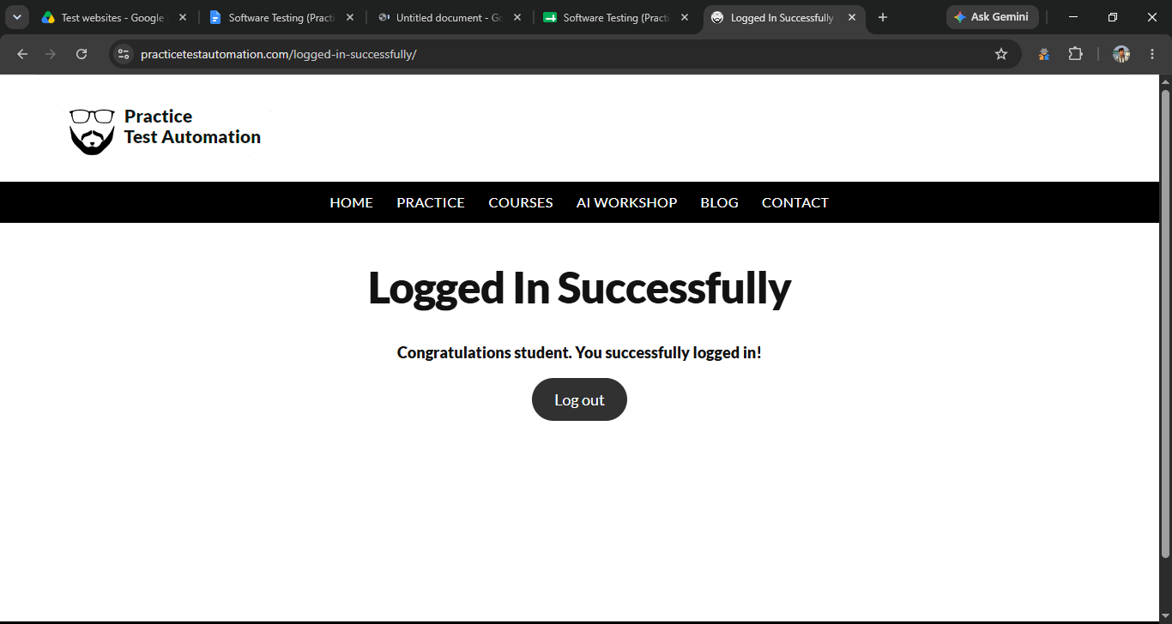

● Scenario ID: 1b
Scenario: Open Login Page
Test Steps:
- Click Signup / Login
- Verify that the login page is displayed
Screenshots:
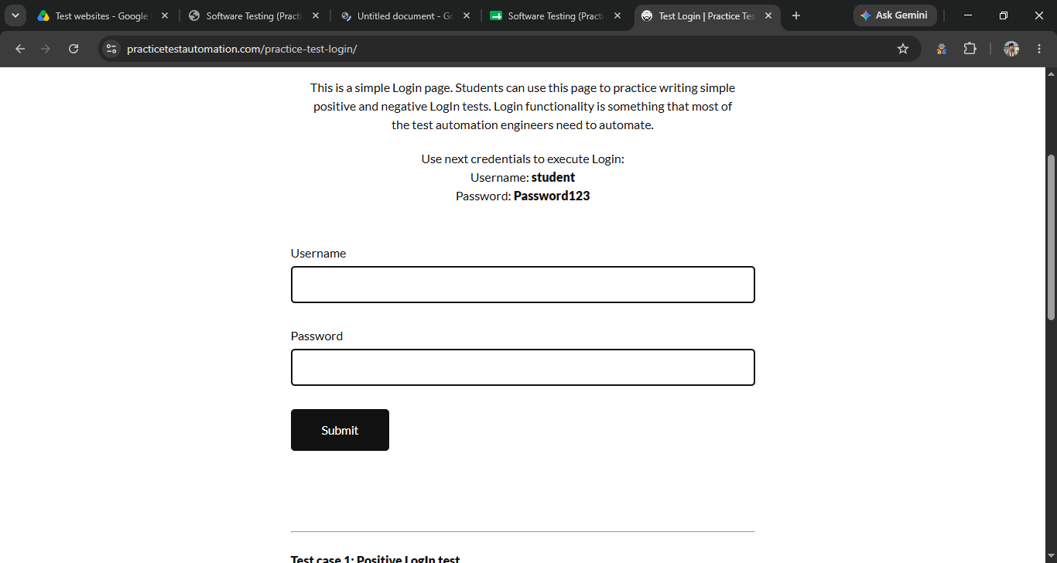

● Scenario ID: 1c
Scenario: Enter Valid Username
Test Steps:
- Enter username in the username/email field
- Verify that the username is accepted
Test Input: student
Screenshots:
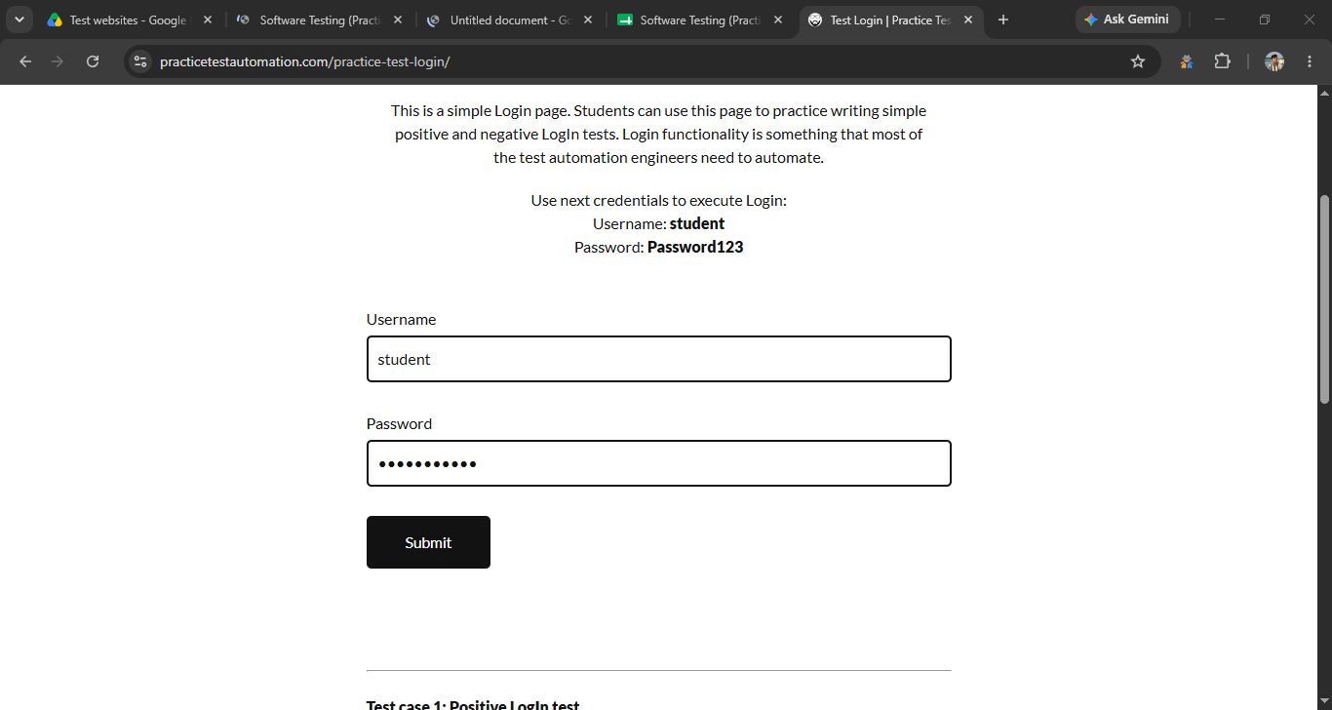

● Scenario ID: 1d
Scenario: Enter Valid Password
Test Steps:
- Enter password in the password field
- Verify that the password is accepted
Test Input: Password123
Screenshots:


● Scenario ID: 1e
Scenario: Login with Valid Credentials
Test Steps:
- Enter valid username/email
- Enter valid password
- Click Login
- Verify successful login
Expected Result: User should login successfully.
Actual Result: Login was successful.
Status: Pass
Screenshots:


● Scenario ID: 1f
Scenario: Login with Invalid Username
Test Steps:
- Enter invalid username/email
- Enter valid password
- Click Login
Expected Result: Appropriate error message should be displayed.
Actual Result: Error message was displayed.
Status: Pass
Screenshots:
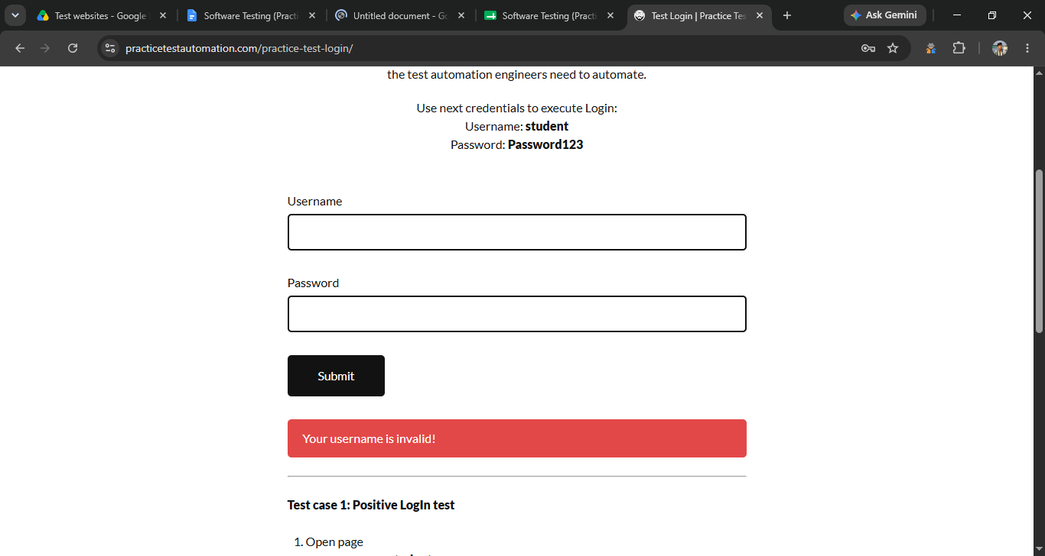

● Scenario ID: 1g
Scenario: Login with Invalid Password
Test Steps:
- Enter valid username/email
- Enter incorrect password
- Click Login
Expected Result: Appropriate error message should be displayed.
Actual Result: Error message was displayed.
Status: Pass
Screenshots:
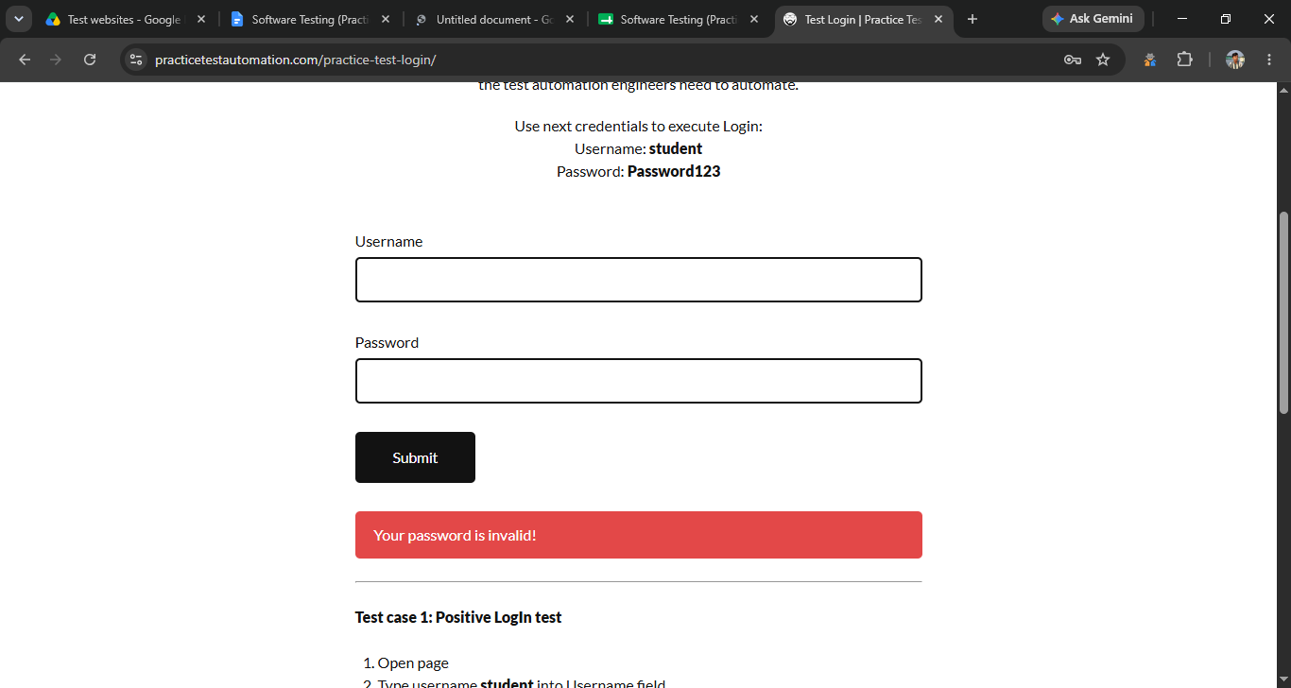

● Scenario ID: 1h
Scenario: Login with Invalid Username and Password
Test Steps:
- Enter invalid username/email
- Enter incorrect password
- Click Login
Expected Result: Login should fail and an error message should be displayed.
Actual Result: Login failed and error message was displayed.
Status: Pass
Screenshots:
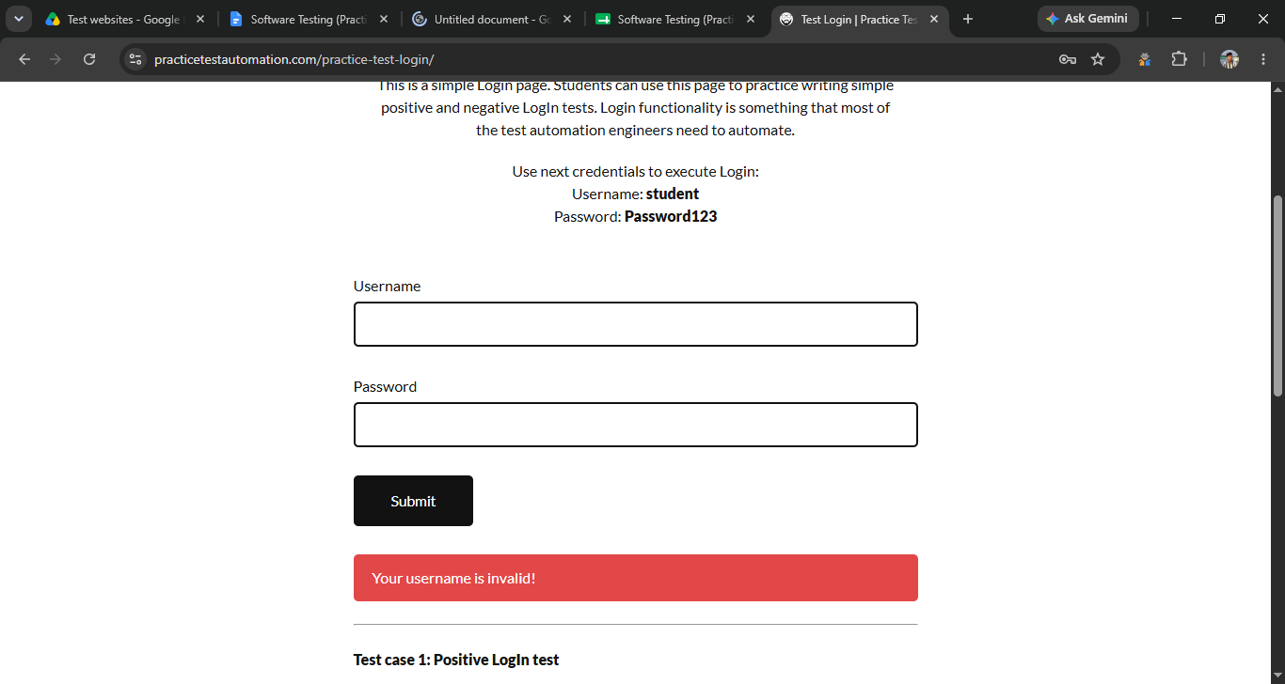

● Scenario ID: 1i
Scenario: Login with Blank Username
Test Steps:
- Leave username/email field blank
- Enter valid password
- Click Login
Expected Result: Username validation should be displayed.
Actual Result: Username validation was displayed.
Status: Pass
Screenshots:


● Scenario ID: 1j
Scenario: Login with Blank Password
Test Steps:
- Enter valid username/email
- Leave password field blank
- Click Login
Expected Result: Password validation should be displayed.
Actual Result: Password validation was displayed.
Status: Pass
Screenshots:


● Scenario ID: 1k
Scenario: Login with Both Fields Blank
Test Steps:
- Leave username/email blank
- Leave password blank
- Click Login
Expected Result: Required-field validation should be displayed.
Actual Result: Validation was displayed.
Status: Pass
Screenshots:
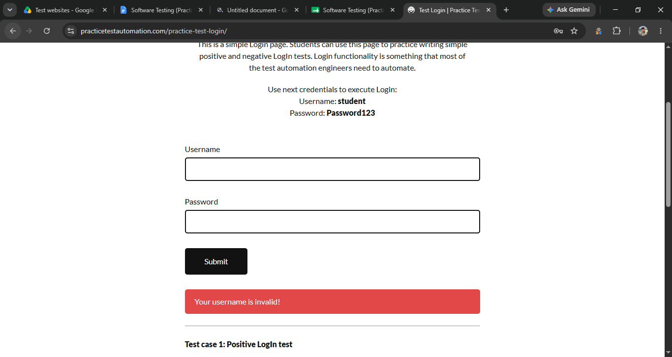

● Scenario ID: 1l
Scenario: Verify Successful Login Redirection
Test Steps:
- Enter valid credentials
- Click Login
- Verify the redirected page
Expected Result: User should be redirected to the logged-in page.
Actual Result: User was redirected successfully.
Status: Pass
Screenshots:


● Scenario ID: 1m
Scenario: Logout
Test Steps:
- Login successfully
- Click Logout
- Verify that the login page is displayed
Expected Result: User should be logged out successfully.
Actual Result: User was logged out successfully.
Status: Pass
Screenshots:
Insert screenshot after logout.

Summary of Test Results
- Total Test Cases: 13
- Passed: 13
- Failed: 0
- Pass %: 100%

● Conclusion and Recommendations
Pass Rate: 100% – Login Module Performs Successfully

● Issues Found
No critical issues were found during the execution of the 13 login test cases.
The valid login, invalid credential handling, blank-field validation, redirection, and logout scenarios worked as expected.

● Recommendations

1. Improve Login Validation
Continue maintaining proper validation for blank and invalid username/password inputs.

2. Maintain Error Handling
Ensure that clear and meaningful error messages are displayed whenever incorrect login credentials are entered.

3. Security Testing
Additional testing can be performed for password security, session management, and multiple login attempts.

